Lab: Text Processing
Problems for exercises and homework for the "Programming Fundamentals" course @ SoftUni.
You can check your solutions in Judge.

Reverse Strings
You will be given a series of strings until you receive an "end" command. Write a program that reverses strings and prints each pair on a separate line in the format "{word} = {reversed word}".

Examples
Input | Output
helLo  Softuni  bottle  end | helLo = oLleh  Softuni = inutfoS  bottle = elttob
Dog  caT  chAir  end | Dog = goD  caT = Tac  chAir = riAhc

Solution
Use while loop and read strings until you receive "end".
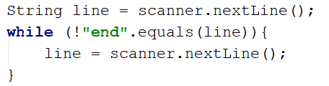
Reverse the String with for loop. Start from the last index and append each symbol to the new String.
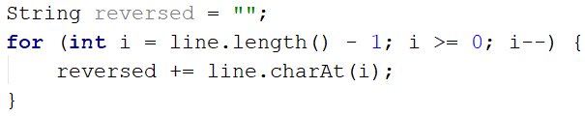
Print the reversed String in the specified format.

Repeat Strings

Write a Program That Reads an Array of Strings. Each String is Repeated N Times, Where N is the length of the String. Print the Concatenated String.

Examples
Input | Output
hi abc add | hihiabcabcabcaddaddadd
work | workworkworkwork
ball | ballballballball

Solution
Read a string array.
Initialize StringBuilder.
Iterate through elements in the array. Find the length of the word at each iteration and append it to the StringBuilder.
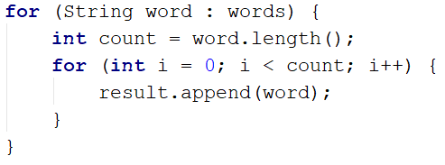
Print the StringBuilder.

Substring
On the first line, you will receive a string. On the second line, you will receive a second string. Write a program that removes all of the occurrences of the first String in the second until there is no match. At the end, print the remaining String.

Examples
Input | Output | Comment
ice  kicegiciceeb | kgb | We remove ice once, and we get "kgiciceeb"  We match "ice" one more time, and we get "kgiceb"  There is one more match. The final result is "kgb"
e  fixture | fixtur

Hints
- Read the input.
- Find the first index where the key appears.
  - Use the built-in method indexOf()
- Remove the match.
  - Use the built-in method replace(String oldValue, String newValue)
- Repeat it until the text doesn't contain the key anymore.

Text Filter
Write a program that takes a text and a string of banned words. All words included in the ban list should be replaced with asterisks "*", equal to the word's length. The entries in the ban list will be separated by a comma and space ", ".
The ban list should be entered on the first input line and the text on the second input line.

Examples
Input | Output
Linux, Windows  It is not Linux, it is GNU/Linux. Linux is merely the kernel, while GNU adds the functionality. Therefore we owe it to them by calling the OS GNU/Linux! Sincerely, a Windows client | It is not *****, it is GNU/*****. ***** is merely the kernel, while GNU adds the functionality. Therefore we owe it to them by calling the OS GNU/*****! Sincerely, a ******* client
computer, programming, set  In computer programming, an application programming interface (API) is a set of subroutine definitions, communication protocols, and tools for building software. | In ******** ***********, an application *********** interface (API) is a *** of subroutine definitions, communication protocols, and tools for building software.

Hints
- Read the input.
- Replace all ban words in the text with an asterisk (*).
  - Use the built-in method replace(banWord, replacement).

Digits, Letters and Other
Write a program that receives a single string and on the first line prints all the digits, on the second – all the letters, and on the third – all the other characters. There will always be at least one digit, one letter, and another character.

Examples
Input | Output
Agd#53Dfg^&4F53 | 53453  AgdDfgF  #^&
a1! | 1  a  !

Hints
- Read the input.
- Use a loop to iterate through all characters in the text. If the char is a digit, print it, otherwise, ignore it.
  - Use Character.isDigit(char symbol)
- Do the same for the letters and other chars.
  - Find something like isDigit method for the letters.

